Dr Martin Reeves
Chief Executive, Oxfordshire County Council
Published and delivered by email

7 March 2023

Dear Dr Reeves,

We write as a matter of urgency about the mounting public concern over the administration’s traffic filter restrictions following the Cabinet’s decision of 29 November 2022.

A Freedom of Information dated 19 January 2023 reveals that certain Council officers, whether on their own initiative or directed by senior Councillors, withheld key traffic impact data that should have been published ahead of or alongside the Council’s public consultation ending on 13 October 2022. The Information was not released until 21 October 2022, a fact omitted or only obliquely referred to in the Cabinet report accompanying the decision. Of greater concern is the Council’s FOI response, in which an officer of this Council is revealed as saying:

“If we change our position by adding the information to the Let’s Talk [Consultation] page, we will have to be prepared to extend the deadline for responses and I’m certain that will mean we will no longer be able to meet the Cabinet and ZEBRA deadline.”

We are deeply concerned that the Council may have made its decision in bad faith and/or that its consultation failed to comply with the Gunning Principles. Either the data was not critical to the Cabinet’s decision, in which case it should have been more clearly referred to the accompanying report, or it was, in which case it should have been included in the consultation.

According to the Sunday Times (5 March 2023) and the Oxford Mail (7 March 2023), the Council appears to have given a further “written commitment” to the Department for Transport on or before 25 March 2022 to approve the restrictions “no later than December” last year. The terms of such commitment are unclear. However, it seems beyond doubt that it was made eight months before the decision to approve the restrictions.

The Council’s position in response to recent media attention has been that the decision was “sound”. We would ask that you urgently investigate the governance surrounding the decision so that public trust in the Council and its consultations can be restored. Assuming that its decision is lawful and its consultation complies with the Gunning Principles, we nonetheless consider that the Council should conduct a further public consultation, accompanied by all traffic data, to engage residents in a more meaningful dialogue about the restrictions.

Given the unprecedented level of public interest in this matter, we are taking the extraordinary step of publishing this letter.

Yours sincerely,
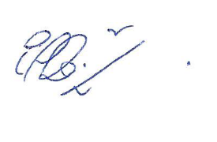 | 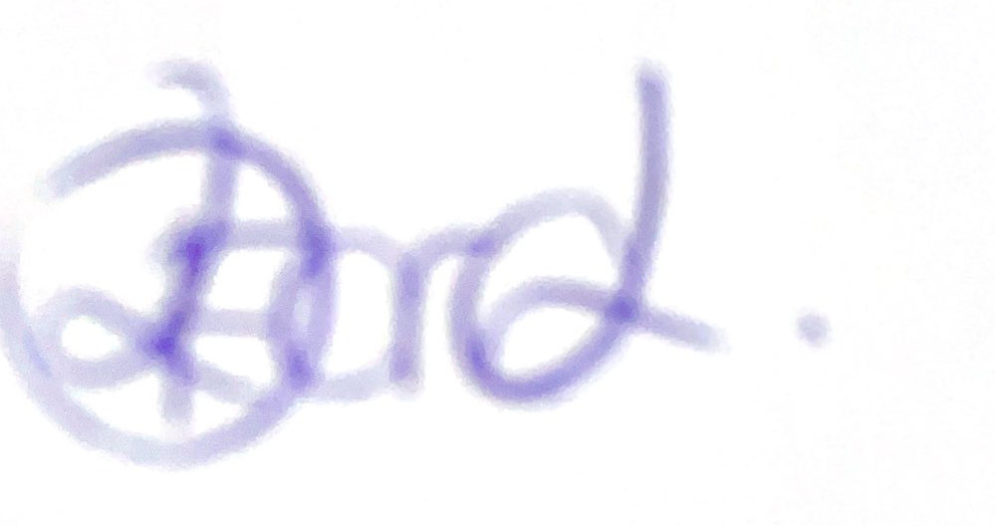 | 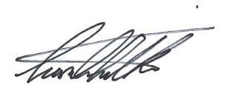
Cllr Eddie Reeves  Leader,  Conservative Group | Cllr Donna Ford  Deputy Leader, Conservative Group | Cllr Liam Walker  Shadow Cabinet Lead, Highways Management

