NAMES OF ATTENDEES AND DIETARY REQUIREMENTS
UP TO 10 PER TABLE | Name and Contact | Dietary Requirements
1.
2.
3.
4.
5.
6.
7.
8.
9.
10.
If you would like to be seated at a specific table,
please state the name of the table host below:
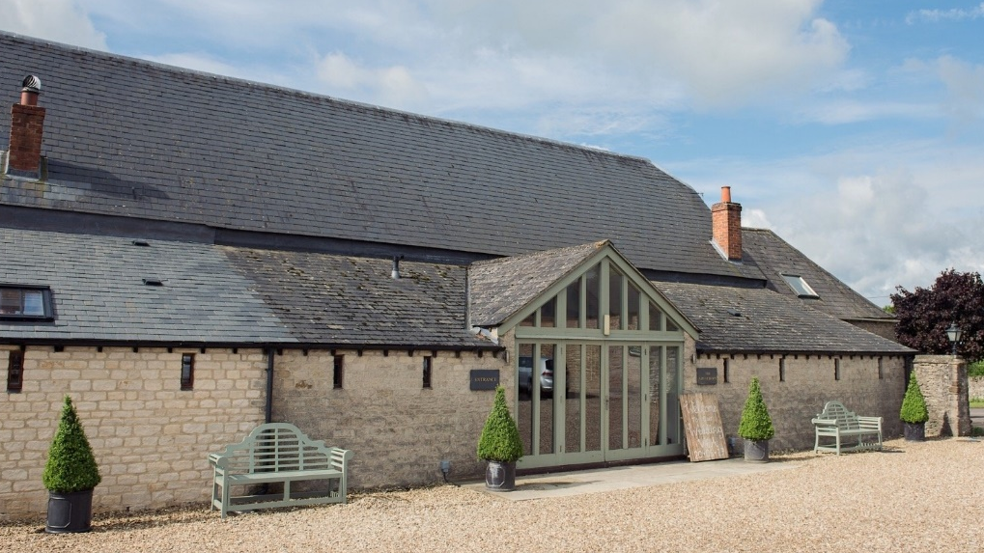
Annual Dinner
North Oxfordshire Conservative Association
invites you to its
Annual Dinner
with The Rt Hon Geoffrey Cox QC MP

at
The Great Barn, Upper Aynho Grounds
7 for 7:30pm, Friday 20 March 2020

We would be delighted for you to join us, and Victoria Prentis MP, at our Annual Dinner as we raise funds towards our 2020 campaign fund.
Organised by our fantastic Social Committee.
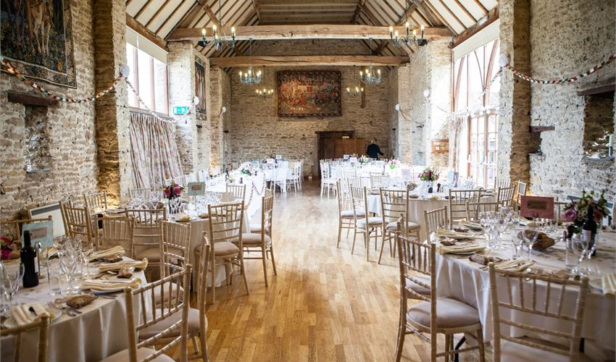

Tickets: £60pp
Dress: Black tie
~
Champagne reception on arrival
Prize draw and fundraising activities

Menu

Labneh with Dukkah, Roasted Heritage Carrot, Honey Dressing and a Cumin Snap (v)

Freshly Baked Assorted Breads
~
Seared Pork Tenderloin and Pressed Shoulder served with a Cider Sauce and Baked Apple, Roasted Sweet Potato and
Tenderstem Broccoli
or Spinach Fennel Pithivier with Rissole Potatoes in a Wild Mushroom Sauce (v)
~
Chocolate and Grand Marnier Bread and Butter Pudding served with Local Cream and an Orange Sauce
Coffee
Promoted by Alana Powell, on behalf of North Oxfordshire Conservatives,
Wykham Park Farm, Wykham Lane, Banbury OX16 9UP

Special guest speaker, Attorney General
The Rt Hon Geoffrey Cox QC MP

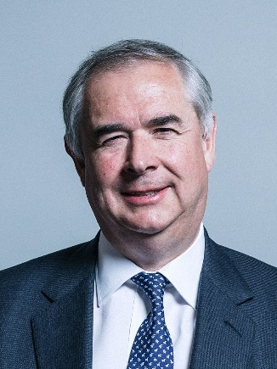
Geoffrey Cox was elected Conservative MP for
Torridge and West Devon in 2005. He was first
called to the Bar in 1982 and in July 2018 was
appointed Her Majesty’s Attorney General for
England and Wales and Advocate General for
Northern Ireland by then Prime Minister
Theresa May. He voted to leave the European
Union in the 2016 referendum. An accomplished
speaker, Geoffrey is renowned for his direct
and passionate Parliamentary speeches.

Total cost of tickets  (£60 per ticket) |  | £
PAYMENT METHOD (please tick one box)
 | CHEQUE  Payable to: North Oxfordshire Conservative Association |  | BANK TRANSFER  Account no.:20681377  Sort code: 20-03-84  Please add reference: Annual Dinner
ONLINE PAYMENT
Please visit: northoxfordshireconservatives.com/events and click the Ticket Tailor link provided to pay via credit or debit card
Please complete and return this booking form with your name and contact details plus a list of attendees (overleaf) with your payment to
North Oxfordshire Conservative Association
Wykham Park Farm, Wykham Lane, Banbury OX16 9U

